**­­­**

Class 8

**Lecture \***

**Digital Electronics**

**(Logic Gates)**

**Digital Electronics**



**Lab Objectives:**

* Number System Conversion-II.

**Logic Gates**

Logic gates are the basic building blocks of any digital system. It is an electronic circuit having one or more than one input and only one output. The relationship between the input and the output is based on a certain logic. Based on this, logic gates are named as AND gate, OR gate, NOT gate etc.

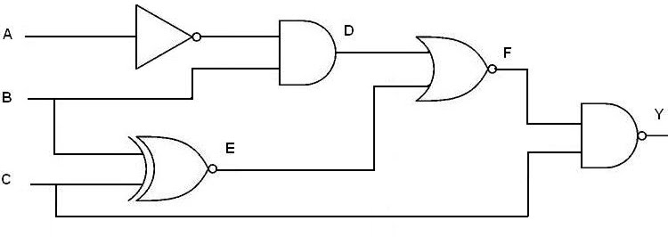

**Truth Table**

A truth table is simply a list of all possible input values to a logic gate (or really any digital circuit) and the output response for each input combination. We usually list the inputs in ascending binary order.

**AND Gate**

The AND gate produces the AND logic function, that is, the output is 1 if input A and input B are both equal to 1; otherwise the output is 0.

The algebraic symbol of the AND function is the same as the multiplication symbol of ordinary arithmetic.

We can either use a dot between the variables or concatenate the variables without an operation symbol between them. AND gates may have more than two inputs, and by definition, the output is 1 if and only if all inputs are 1.

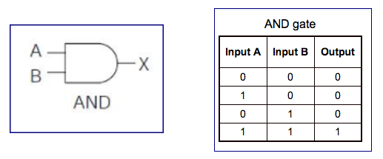

**OR Gate**

The OR gate produces the inclusive-OR function; that is, the output is 1 if input A or input B or both inputs are 1; otherwise, the output is 0.

The algebraic symbol of the OR function is +, similar to arithmetic addition.

OR gates may have more than two inputs, and by definition, the output is 1 if any input is 1.

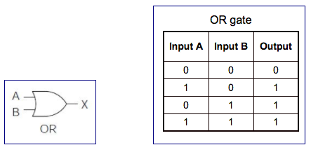

**NOT (inverter) Gate**

The inverter circuit inverts the logic sense of a binary signal. It produces the NOT, or complement, function.

The algebraic symbol used for the logic complement is either a prime or a bar over the variable symbol.

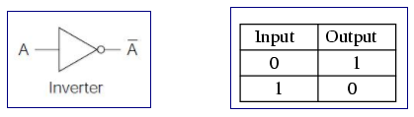

**NAND Gate**

The NAND function is the complement of the AND function, as indicated by the graphic symbol, which consists of an AND graphic symbol followed by a small circle. The designation NAND is derived from the abbreviation of NOT-AND.

